2+6 connector document
- Revision Number:
Rev. 1.0
- Date of Creation or Update:
29/12/2024
- Prepared By:
Muhammad .Sulaiman Shahid
- Reviewed By:

- Approved By

Introduction to 2+6 Connector
The 2+6 connector is a specialized type of electrical connector widely used in EV charging infrastructure and industrial applications. It combines two primary power pins (2) and six auxiliary pins (6) to support both high-power transmission and additional communication or control functions.

Key Features:
- High Power Transmission:
The two primary pins are designed to handle significant electrical loads, making the connector suitable for applications requiring robust power delivery, such as EV fast chargers.
- Auxiliary Functions:
The six auxiliary pins facilitate communication, control, or auxiliary power functions, ensuring seamless operation and integration with various systems.
- Versatility:
Its design makes it adaptable for use in multiple environments, including EV charging stations, industrial machinery, and other high-demand applications.
- Durability:
The connector is typically built with high-quality materials to withstand environmental stresses, ensuring long-term reliability.
This connector plays a crucial role in advancing EV technology by ensuring efficient and reliable power delivery along with necessary communication capabilities.

Sample harness of 2+6 connector
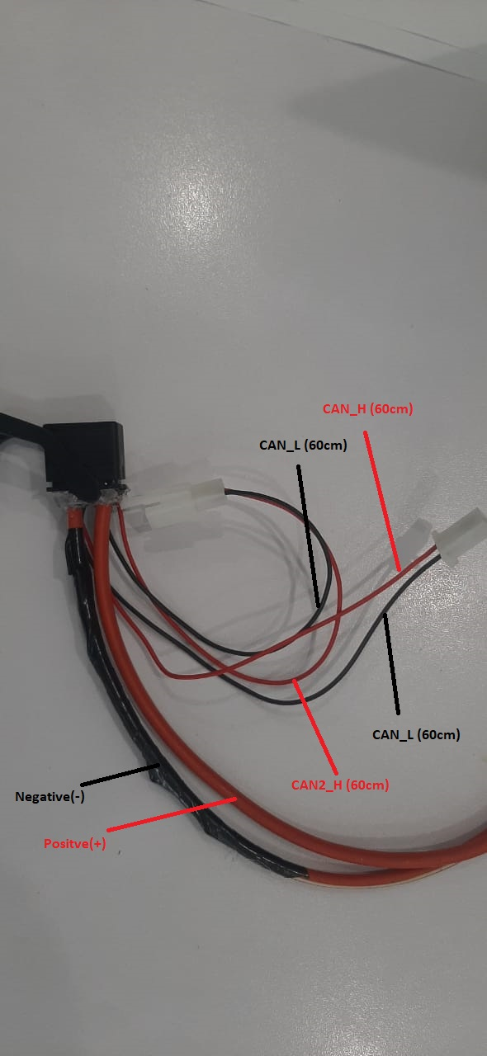

This sample harness of 2+6 connector has been provided to the supply chain team to be modified and replaced with an Anderson connector, as previously utilized in the bike HV harness diagram.

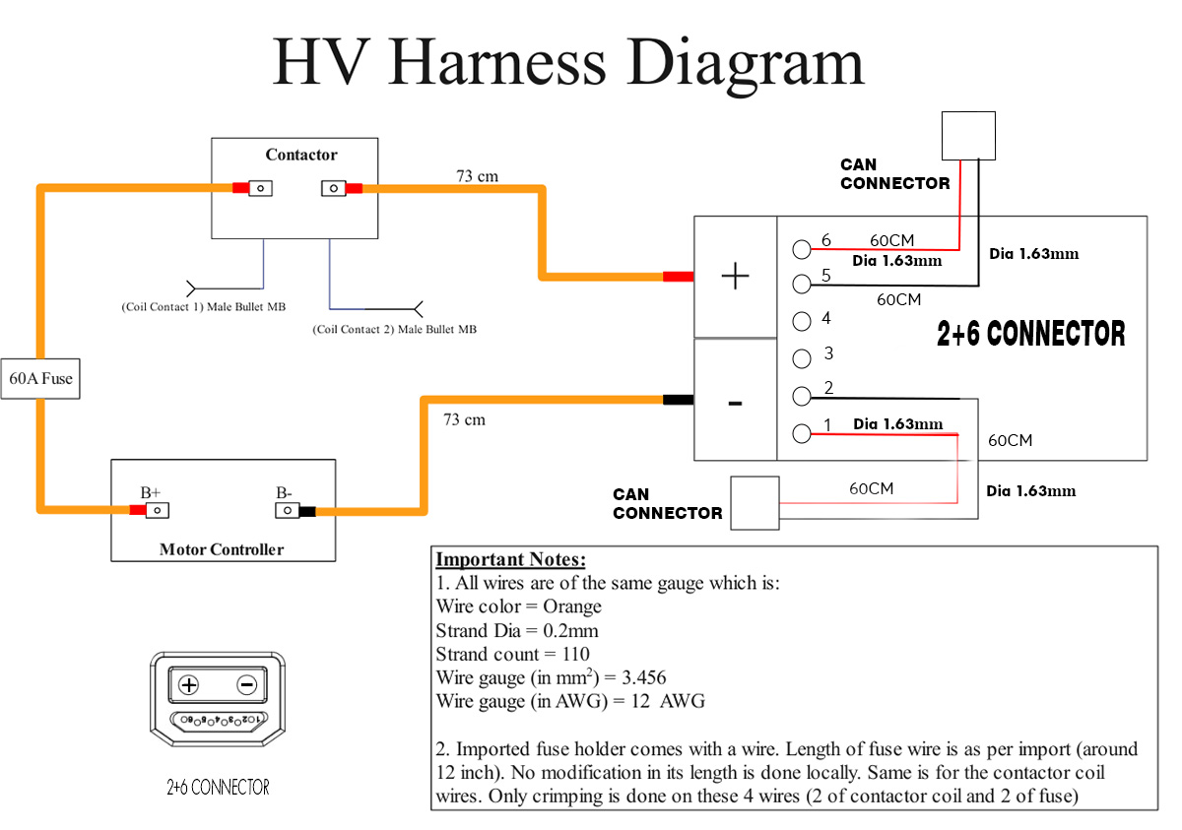
HV harness diagram

This is the HV harness diagram in which the Anderson connector has been replaced with a 2+6 connector. The auxiliary pins of the 2+6 connector are utilized for transmitting CAN data.
Length of CAN data wire in 60cm and diameter is 1.63mm

